International School

Project Proposal Document
Course: System Integration Practices
Project Title: Company X – Integrated HR & Payroll Management Dashboard
Case Study 1: Problem Statements
Version: 1.0
Date: 27/01/2026
Group: Thrainh / 5
Semester: 2 – 2026
Instructor: Nguyen Dang Quang Huy
Team Members:
Thong, Le Huu | - 29219038101
Minh, Vo Van | - 29219261748
Doan, Ba Rin | - 29219037721
Tai, Su Phat | - 29211162809
Vinh, Nguyen Tran Xuan | - 29211138585

Approved by
MSc Huy, Nguyen Dang Quang
Group Project - Instructor:

Name Signature Date

Da Nang 02/2026
Project Acronym | HRD
Project Title | Company X – Integrated HR & Payroll Management Dashboard
Start Date | 25 Jan 2026 | End Date | 1 Feb 2026
Lead Institution | International School, Duy Tan University
Role | Name | Email |  | Phone
Project Mentor | Nguyen Dang Quang Huy
 | Le Huu Thong | bass030196@gmail.com |  | 0768463655
 | Su Phat Tai | phattai0935@gmail.com |  | 0766657942
 | Doan Ba Rin | doanbarin@gmail.com |  | 0766721747
 | Nguyen Tran Xuan Vinh | xuanvinh2005nh@gmail.com |  | 0845015537
 | Vo Van Minh | vanminhvo2005@gmail.com |  | 0707944067

DOCUMENT NAME
Document Title | Software Project Proposal Document Specification Document
Reporting Period | – February - 2026
Author(s) | Le Huu Thong  Vo Van Minh  Su Phat Tai  Doan Ba Rin  Nguyen Tran Xuan Vinh
Role | Developer
Date | 27/01/2026 | File name | 1. Proposal Document_IEEE 830-1998.docx

DOCUMENT APPROVALS
Document Approvals: The following signatures are required for approval of this document.
Mentor | Huy, Nguyen Dang Quang | Signature:
 |  | Date:
Team member(s) | Thong, Le Huu | Signature:
 |  | Date:
 | Tai, Su Phat | Signature:
 |  | Date:
 | Minh, Vo Van | Signature:
 |  | Date:
 | Rin, Doan Ba | Signature:
 |  | Date:
 | Vinh, Nguyen Tran Xuan | Signature:
 |  | Date:

TABLE OF CONTENTS

1. Introduction 6
1.1 Purpose of the Document 6
1.2 Scope of the Document 6
1.3 Definitions, Acronyms, Abbreviations 6
1.4 References 7
1.5 Overview 7
2. Project Overview 8
2.1 Background 8
2.2 Business Motivation 8
3. Business Problem Analysis 8
4. Proposed Solution 9
4.1. System Integration Approach 9
4.2. Key Dashboard Functions 9
4.3. Security Technologies (REST, JWT) 10
4.4. Business Function Diagram: 11
4.5. System Context Diagram: 11
5. Project Objectives 12
5.1 General Objective 12
5.2 Specific Objectives 12
6. Project Scope, Assumptions, and Constraints 12
7. System Architecture and Technology Stack 13
8. Project Planning and Milestones 14
9. Estimated Resources and Cost (for Educational Purposes) 15
10. Expected Outcomes 15

1. Introduction

1.1 Purpose of the Document
- This document is intended to provide an overview of the project, including its purpose and scope.
- It identifies the business needs, problems, or situations related to project initiation.
- It provides solutions to business needs and an overview of the system architecture.
- It provides an overview of the resources, schedule, solutions, and budget for the project.
- The target audience for this document includes students and faculty.

1.2 Scope of the Document
- Functions for managing employee records, employment contracts, and insurance.
- Timekeeping procedures, leave management, and calculation of salaries, bonuses, and personal income tax (PIT).
- Dashboard design for statistical reporting on personnel changes and payroll.
Documents not included:
- Recruitment and onboarding process.
- General accounting and financial operations unrelated to payroll.
- Time attendance hardware system (fingerprint scanner/Actual Face ID).

1.3 Definitions, Acronyms, Abbreviations
Acronym | Definition
HRM | Human Resource Management
API | Application Programming Interface
BRD | Business Requirement Document
SRS | Software Requirements Specification
PIT | Personal Income Tax
CRUD | Create, Read, Update, Delete
UI/UX | User Interface / User Experience

1.4 References
- [Nguyễn Đăng Quang Huy], "Course Lectures: System Integration Practices," International School, Duy Tan University, [ second semester – 2026]
- Company X Management, "Case Study 1: Problem Statements & CEO Memo," Project Documentation, [2026].
- IEEE Computer Society, "IEEE Std 830-1998: IEEE Recommended Practice for Software Requirements Specifications," 1998.
- Microsoft, "SQL Server Technical Documentation," [Online]. Available: https://learn.microsoft.com/en-us/sql/.
- Oracle, "MySQL Documentation," [Online]. Available: https://dev.mysql.com/doc/.

1.5 Overview
Phần 1: Introduction
Phần 2: Project Overview
Phần 3: Business Problem Analysis
Phần 4: Proposed Solution
Phần 5: Project Objectives
Phần 6: Project Scope, Assumptions, and Constraints
Phần 7: System Architecture and Technology Stack
Phần 8: Project Planning and Milestones
Phần 9: Estimated Resources and Cost
Phần 10: Expected Outcomes

2. Project Overview

2.1 Background
The enterprise already possesses its own information management system. However, the HR and Payroll systems—which are related in terms of data—operate completely separately from one another. Currently, data between the two systems is duplicated, and asynchronous data entry is causing management costs to increase unnecessarily.

2.2 Business Motivation
Since both systems are currently operating stably and without errors, the CEO has requested an integration project. The enterprise aims to synchronize data between the two systems to eliminate data duplication, reduce management costs, and support rapid decision-making.

3. Business Problem Analysis

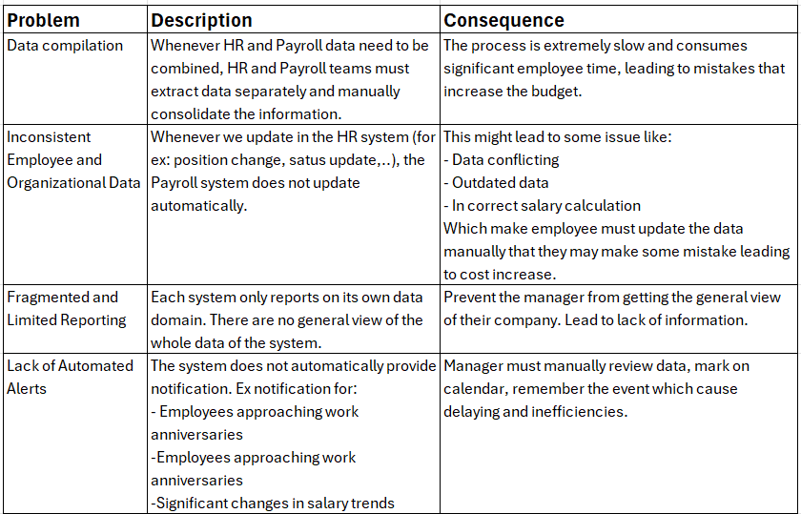

4. Proposed Solution

4.1. System Integration Approach
To address the issue of fragmented data, the team proposes building an "Integrated HR & Payroll Management Dashboard" solution operating on a Microservices-oriented architecture. The system acts as a Centralized Hub, connecting two heterogeneous data sources through a Middleware API Layer.
- Multi-source Connection: The Backend system will establish parallel connections:
- Channel 1: Connects to SQL Server (HUMAN_2025) via database driver libraries to retrieve personnel and attendance data.
- Channel 2: Connects to MySQL (PAYROLL) via the corresponding driver to retrieve salary, bonus, and insurance data.
- Data Mapping & Aggregation: Data from both sources will be mapped based on the primary key EmployeeID. When a user requests to view a profile, the API will automatically fetch personal information from SQL Server and salary information from MySQL, then merge them into a single JSON object to return to the Dashboard.

4.2. Key Dashboard Functions
- User Authentication (Login): Authenticate users via Email/Password and issue access tokens (JWT).
- Safe Logout: Terminate the current user session securely.
- Role-Based Access Control (RBAC): Enforce distinct access privileges for Admins (full access) and Employees (personal view only).
- KPI Overview: Display key metrics such as Total Employees, Total Payroll Cost, and New Hires for the current month.
- Data Visualization: Visualize real-time data using charts for personnel distribution and salary cost trends.
- Unified Employee Profile View: Aggregate and display personal details (from SQL Server) and salary information (from MySQL) on a single screen.
- Global Search: Allow users to search for employee records by Name or ID across both databases simultaneously.
- Monthly Payslip Viewer: Display detailed breakdowns of salary, bonuses, tax, and insurance for selected months.
- Data Consistency Check: Scan and identify discrepancies or missing records between the HR and Payroll databases.
- Report Export: Generate and export salary data and employee lists to standard formats (Excel, PDF).

4.3. Security Technologies (REST, JWT)
Authentication: Utilizes JWT (JSON Web Token) for secure, stateless session management (ensuring no session state is stored on the server).
Authorization: Implements the Role-Based Access Control model:
- Role Admin/Manager: Grants full access to all data sets and synchronization features.
- Role Employee: Restricted to viewing only their own personal information.
Data Protection: User passwords are hashed using the Bcrypt algorithm. All API communications are encrypted and secured via the HTTPS protocol.

4.4. Business Function Diagram:

4.5. System Context Diagram:
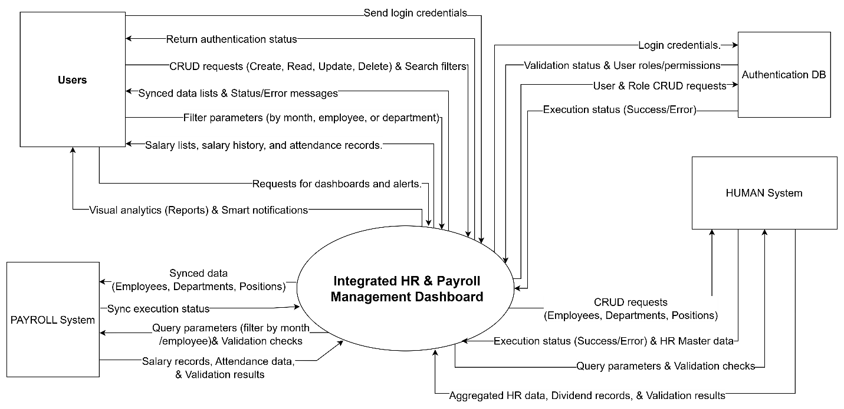

5. Project Objectives

5.1 General Objective
Develop a dashboard system to integrate two independent HR and Payroll systems without modifying the existing data.

5.2 Specific Objectives
Analyze business requirements from customers to define necessary functions.
Design the system architecture.

6. Project Scope, Assumptions, and Constraints
Project Scope
In Scope | - Build a dashboard system that connects the HR and Payroll database management systems via APIs.  - Develop a human resource management system.  - Develop a reporting and chart analysis system.  - Develop a notification system for company events.
Out of Scope | - Do not modify the table structure in the database.  - Do not replace or rewrite the system's core functions.
Assumptions | - The project is carried out for educational purposes.  - The HR and Payroll systems are operating stably, with existing data ready for integration.  - Authorized access to both databases is granted.
Constraints | - Utilize Python, React, SQL Server, and MySQL.  - Maintain the original source databases.  - Successfully integrate both SQL Server and MySQL databases.

7. System Architecture and Technology Stack
- Frontend Layer:
This is where users interact directly with the system via the Dashboard interface.
- Backend Layer:
Acts as the "brain," controlling the entire business logic of the Dashboard.
- Integration Layer:
The most critical layer, serving as the intermediary that connects and synchronizes data with SQL Server and MySQL.
- Database Layer:
Includes the two existing databases and a newly created authentication database.
Layer | Technology | Description
Backend | Python | Provides API services to handle integration logic and HR management workflows.
Database | SQL Server (HUMAN_2025), MySQL (PAYROLL) | The company's existing core data sources.
Frontend | React.js | Builds a modern Dashboard interface, supporting interactive charts and visual reporting.
Authentication | SQL Server | A separate database dedicated to storing user accounts, roles (RBAC), and system logs.
Integration Layer | Entity Framework / SQLAlchemy | Data Access Layer (DAL) that facilitates reading/writing data from two heterogeneous systems via direct connections or APIs.
Testing | Postman, Jest / PyTest / xUnit | Uses Postman for integration API testing. Uses Jest (for Frontend) or PyTest/xUnit (for Backend) to perform Unit Tests, ensuring accurate data synchronization logic.
DevOps (Optional) | GitHub, Docker (Optional) | GitHub is used for source code management and team collaboration. Docker can be used to containerize the Dashboard environment, ensuring consistent and easy deployment to the testing environment.

8. Project Planning and Milestones

Week | Case Study | Deliverables | Key Activities
1–2 | Case Study 1 | Project Proposal, Project Plan, BRD | Analyze problem and define objectives
3–4 | Case Study 2 | SRS, UI/UX Design, Data Mapping | Design system model and integration logic
5 | Case Study 3 | API Implementation | Develop backend APIs for CRUD operations
6 | Case Study 4 | Security Integration | Implement authentication & authorization
7–9 | Case Study 5 | Final Dashboard | Integrate APIs, reports, and alerts

9. Estimated Resources and Cost (for Educational Purposes)
Resource | Description | Cost
Development Tools | VS Code, Visual Studio, MySQL Workbench | Free
Database Systems | Microsoft SQL Server Express (cho HUMAN_2025), MySQL Community Server (cho PAYROLL) | Free
API & Testing | Postman: Used to test the read/write data requirements of the integrated API. | Free
Design & Diagrams | Figma hoặc Draw.io: Used for drawing BFD diagrams, System Context Diagrams, and designing UI Dashboards. | Free
Collaboration | GitHub: Used for source code management and teamwork. | Free
Documentation | Microsoft Word / Google Docs: Used for drafting proposals and case study reports. | Free

10. Expected Outcomes
Upon completing this project, students should be able to:
Apply system integration models to solve real-world business problems effectively.
Design and develop RESTful APIs to handle data synchronization logic between heterogeneous databases (SQL Server & MySQL).
Perform Business and System Analysis to identify requirements, constraints, and data inconsistencies in a corporate environment.
Architect Integration Solutions, including Data Mapping schemas and Security protocols (JWT, RBAC)
Develop interactive Dashboards and Analytics tools for real-time decision-making support.
Experience a Full-cycle Project Deployment, from proposal planning to final system testing and documentation.
Appendices
Appendix A: Summary of CEO Memo
Appendix B: Preliminary Gantt Chart
Appendix C: Initial System Context Diagram

